

**CEE 598 – Traffic Simulation Modelling and Applications**

**Instructor: Professor Xuesong Zhou**

**Lesson 1.1**

**Done by: Mohamed Jatit**

1. Number of nodes = 149

Number of Zones = 41

1. Speed Limit = 39 mph

Number of lanes = 2 lanes

1. Link capacity is the capacity for multiple lanes while Lane capacity is the capacity of a single lane.
2. The link capacity for S Redwood Rd is (2562) between nodes 5436 through 11160, and then it decreases to 1784 between nodes 11172 to 5112. Also, it then decreases again to (929) between nodes 5238 to 5208
3. The number of agents/vehicles as reported in the output summary is 12638 vehicles.
4. Average travel time = 6.43 minutes

Average Trip Time Index = 1.16

Average speed = 28.18

Network clearance time = 1440 minutes

1. Average travel time = 11.417 minutes

Average Trip Time Index = 2.052

Average speed = 15.96

Network clearance time = 1440 minutes

After decreasing the number of lanes in the perspective work zone from 2 lanes to 1 lane, we can notice an increase in the average travel time from 6.43 minutes to 11.417 minutes. The average trip time index also increases from 1.16 to 2.052 and the Average speed decreases from 28.18 to 15.96 mph.

1. Link MOE Plots:
2. Link from Node 1 to 2:

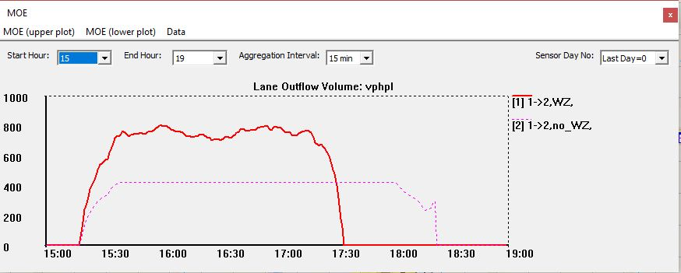

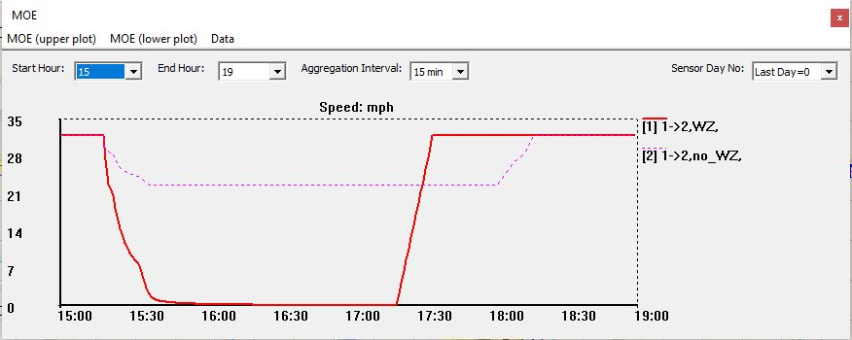

1. Link from node 2 to 1:

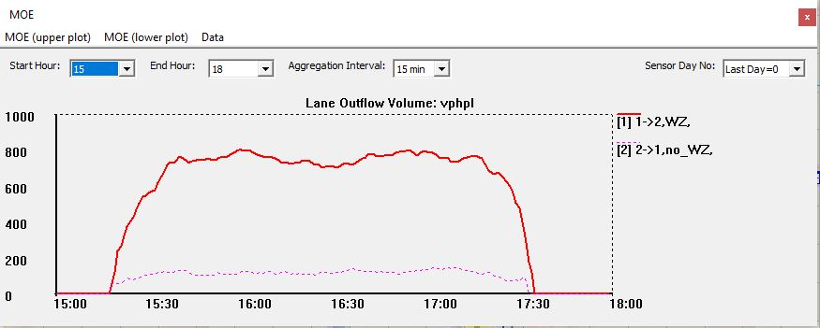

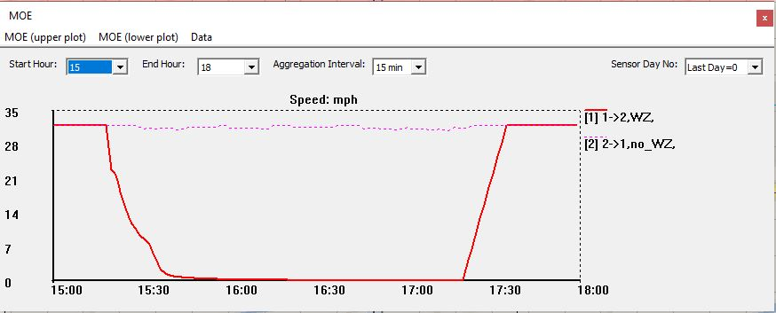

1. Link from node 1 to 2:

It can be noticed from the graphs that the Lane Volume is much higher (800 vphpl) in the work zone condition compared to the condition without a work zone (400 vphpl) which is a clear result of reducing the number of lanes from 2 to 1.

It can be noticed that the speed in the work zone condition is almost zero which means that there’s a congestion and the vehicles are hardly moving. The results are also shown from 15:00 PM to 19:00 PM which is typically the rush hour and traffic is usually congested at this time of the day and the speed increases after 17:00 PM which is typically when the rush hour traffic congestion starts decreasing.

Also, It can be noticed that the speed in the no work zone condition is about 22 mph and the results are also shown from 15:00 PM to 19:00 PM which is typically the rush hour and traffic is usually congested at this time of the day and it can be seen that the speed goes back to normal after 18:00 PM to about 30 mph which is typically when the rush hour traffic congestion starts decreasing.

Link from node 2 to 1:

It can be noticed from the graphs that the Lane Volume is much higher (800 vphpl) in the work zone condition compared to the condition without a work zone (200 vphpl) which is a clear result of reducing the number of lanes from 2 to 1.

It can be noticed that the speed in the work zone condition is almost zero which means that there’s a congestion and the vehicles are hardly moving. The results are also shown from 15:00 PM to 19:00 PM which is typically the rush hour and traffic is usually congested at this time of the day and the speed increases after 17:00 PM which is typically when the rush hour traffic congestion starts decreasing.

Also, it can be noticed that the speed in the no work zone condition is about 30mph and the results are also shown from 15:00 PM to 19:00 PM which is typically the rush hour and traffic is usually congested at this time of the day and the speed stays the same through out the specified time period at about 30 mph.

After analysing both conditions and looking at the speed and volume patterns, it can be confirmed that the link from node 1 to 2 is experiencing more congestion than the link from node 2 to 1.